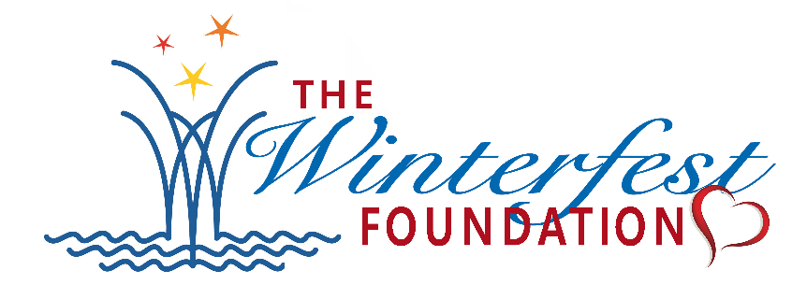
NEWS RELEASE

FOR MORE INFORMATION:
Kathy Keleher, Winterfest, Inc.
954-767-0686, kathy@winterfestparade.com
Website: winterfestfoundation.org
FB: WinterfestFoundation

IMMEDIATE RELEASE: April 23, 2021

The Winterfest Foundation Inspires Creativity In Local Students!
673 Budding Artists Entered 2021 Winterfest® Fantasy Boat Student Art Contest.

Broward County Students & Teachers to Take Home Awards and Cash Prizes!

Broward County, FL- The Winterfest® Foundation recently completed the judging for the 2021-2022 Foundation Winterfest® Fantasy Boat Student Art Contest.
This year, 673 students from Broward County public, private, and charter schools used their imagination and artistic talents to draw pictures depicting a boat design they would like to see in the annual Seminole Hard Rock Winterfest® Boat Parade. The artwork from students in Kindergarten - 5th grades is on display at the Museum of Discovery and Science from April 23-25, 2021. The Winterfest® Foundation Awards Exhibit is supported by BBX Capital Foundation and first place winners in categories Grades K-1, 2-3, 4-5 will be receiving laptops courtesy of Dania Pointe. All participating students and families, teachers, and principals are invited to the Awards Reception on Sunday, April 25, 2021, from noon to 5 pm. Awards will be given out from 1:30-2 PM.

This year’s judges were local artist Dennis Friel, the Museum of Discovery & Science President & CEO, Joseph Cox, and Winterfest past poster artist, Brooke Trace.

Two special awards will be given out:
Museum Award was chosen by Joseph Cox of the Museum of Discovery and Science
A Guy Harvey Ocean Foundation Award in recognition of the 2021 partnership of their S.T.E.A.M. Education Program with the Winterfest Foundation. Because of this developing partnership, Jessica Harvey, Project Manager for the Foundation picked a piece of art to be rewarded. The Guy Harvey Ocean Foundation (GHOF) conducts scientific research and hosts educational programs aimed at conserving the marine environment. The GHOF funds affiliated researchers working to better understand the ocean ecosystem and educators helping to foster the next era of marine conservationists.

Three 1st Place students will receive laptops; Cash prizes will be given to second and third place winners in each grade category. All winners will receive a heart-warming prize: their artwork specially framed with a plaque noting their winning status. A copy of the framed artwork will also be given to their school. All and all honorable mentions will receive merchandise from the Guy Harvey Ocean Foundation.

CONTEST WINNERS:

GRADES K-1
1st PLACE: Samide Joseph- Village Elementary
2nd PLACE: Mia Santiago- Coral Cove Elementary
3rd PLACE: Isaac Walsh Daniels - North Broward Academy of Excellence
HONORABLE MENTION:
Blake Sears - Village Elementary
Danila Grant Simpson - Village Elementary
Isabella Burgio - St. Bonaventure Catholic

GRADES 2-3
1st PLACE: Sophia Sanchez - St. Bonaventure Catholic
2nd PLACE: Jaizon Williams - Village Elementary
3rd PLACE: Kayla Jean - Village Elementary
HONORABLE MENTION:
Alia Castro - St. Bonaventure Catholic
Pedro Mendiri - St. Bonaventure Catholic
Samatha Young - St. Bonaventure Catholic

GRADES: 4-5
1st PLACE: Ann Guilloume - Village Elementary
2nd PLACE: Reese Randall - St. Bonaventure Catholic
3rd PLACE: Stella Flower - Floranada Elementary
HONORABLE MENTION:
DeShawn Pink - Village Elementary
Stelmaria Llano - St. Bonaventure Catholic

MUSEUM AWARD: Alicia Persaud - Floranada Elementary
GUY HARVEY OCEAN FOUNDATION AWARD: Ryleigh Ann Walkup - Floranada Elementary

For more information on the Winterfest® Foundation Student Art Contest with the Awards Reception on April 25, 2021, or other events, please contact the Winterfest® office at 954-767-0686 or visit www.winterfestfoundation.org.

About THE WINTERFEST FOUNDATION. Founded in 2017, The Winterfest® Foundation (501C3) was created to support the South Florida community. The organization’s focus is education, arts and culture in public places, water safety, and assisting other charitable sectors. The Winterfest Foundation does this by providing resources, communication, and funds. The foundation encourages charitable organizations, schools and the community to use the opportunities given by the Foundation to
- Encourage parent and public involvement in the public schools of Broward County.
- Develop relationships between educators and the general public with united efforts
- Support art projects in schools and in Public Places the community
- Assist Broward County non-profit organizations with the ability to communicate their mission to a larger audience
- Support organizations in their development of water safety awareness
For more information on Winterfest®, please contact the office at (954) 767-0686 or their website: www.winterfestfoundation.org

ABOUT THE MUSEUM OF DISCOVERY AND SCIENCE (MODS)
Founded in 1976 as the Discovery Center, today MODS is at the forefront of science education, innovation and exploration. The Museum showcases more than 300 interactive exhibits, immersive films and experiential programs. MODS is committed to The Museum celebrates diversity and welcomes more than 400,000 visitors annually from all walks of life. MODS is open every day of the year, except for Thanksgiving, one day in the spring for its Annual Wine, Spirits and Culinary Celebration (March 13, 2020) and one day in the fall for the Annual Gala (October
24, 2020). Hours are Monday through Saturday from 10 a.m. to 5 p.m., and Sunday from noon to 5 p.m. MODS is located downtown at 401 SW Second Street, Fort Lauderdale, Florida 33312. For more information about the Museum, call 954.467.MODS (6637) or visit mods.org

BBX Capital Foundation
The BBX Capital Foundation is a 501(c)(3) corporate foundation. Since its inception, the Foundation has awarded more than $20 million in contributions and in-kind services to charitable organizations throughout the state of Florida. The BBX Capital Foundation focuses on three key areas: the arts, education’ and human services. It considers requests for specific projects as well as for general programs.

The Guy Harvey Ocean Foundation
The Guy Harvey Ocean Foundation (GHOF) conducts scientific research and hosts educational programs aimed at conserving the marine environment. The GHOF also funds affiliated researchers working to better understand our ocean ecosystem and educators helping to foster the next era of marine conservationists. The GHOF will help ensure that future generations can enjoy and benefit from a properly balanced ocean ecosystem. Follow the GHOF on Facebook, Twitter and Instagram at @guyharveyocean. For more information, visit www.GHOF.org.

###

